**ILLUSTRATION OF A FISHBONE DIAGRAM.**

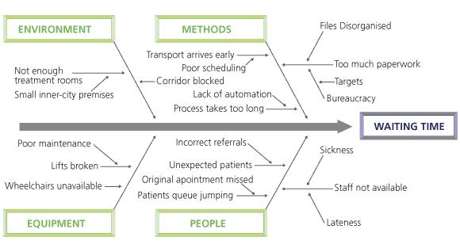

The purpose of this diagram is to look at the root causes of a problem. The diagram above from the Institute of Innovation and improvement shows the problem of waiting time[1]. The category headings act as prompts to encourage you to consider a wider range of factors creating the problem.

If your practice is not achieving the target blood pressure in a significant number of your patients with diabetes you could construct a fishbone diagram (as it looks like the skeleton of a fish), also called cause and effect analysis.

The head states the problem:

*Target blood pressures not being achieved*

You then have a meeting to identify the major categories of the potential causes or use generic headings such as ‘environment’, ‘people’, ‘equipment’ and ‘measurement’. These form the spines of the fish.

Major categories for the example of not achieving target blood pressure could be;

*Patient*

*Doctor*

*Process*

You can then discuss each major category, adding the ideas generated as sub-branches. Each sub-branch may be further broken down into its contributing factors. For every spine and sub-branch identified, ask yourself ‘Why does this happen?’ and consider the question from different perspectives - such as patient, administrator, nurse, doctor, clinical commissioning group. This will produce the layers of causes that will help you to fully understand the root of the problem and its dependencies.

The diagram shows the start of entering the causes which are not exhaustive.

TREATMENT TARGET FOR BLOOD PRESSURE NOT BEING MET

**DOCTOR**

**PATIENT**

No prompt on

computer screen

Poor concordance

with therapy

Not aware of target

Side effects

Does not believe target appropriate

Maximum

Tolerated therapy

**TARGET BP NOT**

**BEING MET**

BP not being taken

Abnormal BPs not being followed up

No search for abnormal BP

Nurse finds it difficult to find GP to discuss BP Management

**PROCESS**

The exercise is best conducted in a group comprising everyone involved or effected by ‘the problem’. Once you have your diagram, you can decide which cause is tackled first.

1. Fishbone diagram: TIN, now the East Midlands Improvement Network, and Dave Young. Cause and Effect (Fishbone). *The Handbook of Quality and Service Improvement Tools*. NHS Institute for Innovation and Improvement, 2008. <http://www.institute.nhs.uk/quality_and_service_improvement_tools/quality_and_service_improvement_tools/cause_and_effect.html> [accessed 28 May 2015].