**ILLUSTRATION OF MODEL FOR IMPROVEMENT/PDSA CYCLES**

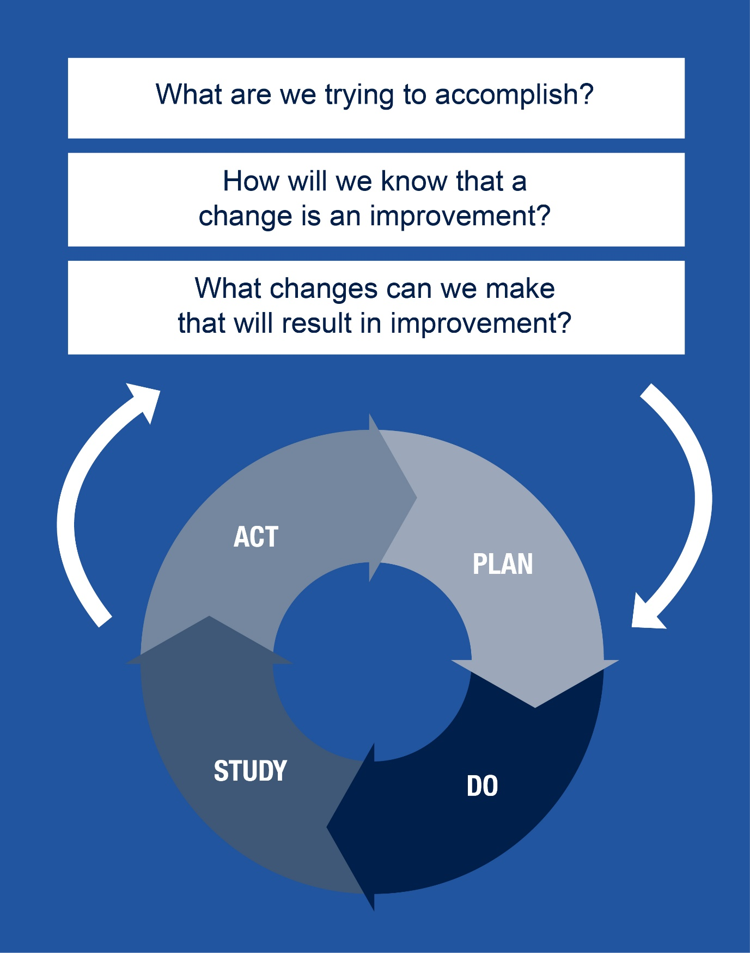

The ‘Model for Improvement’ gives you three questions to answer before you start testing changes[1]:

**Question 1: What are we trying to accomplish?**

This needs to be specific and include ‘by how much?’ and ‘by when?’.

For example:

*‘increase attendance for review of diabetes’* is not very specific.

A more specific aim would be:

*‘increase attendance for those invited for review of diabetes over the next 3 months by 20%”*

**Question 2: How will we know if a change has been an improvement?**

In order to know if your ideas for change are working, you will need to decide what you are going to measure.

Continuing the review of diabetes example:

*Count the number of responding to invitation for review of diabetes every week*

**Question 3: What changes can we make that will result in improvement?**

To answer this question you gather together all the ideas for change that you would like to test.

In our example, the practice agrees to test three ideas:

* *No appointment time stated on review letter but patients to make their own appointment*
* *Invitation sent out in first choice language*
* *Invitations made by phone call*
* *Leaflet on the importance of review sent out with each invitation*
* *Review appointment request attached to prescription*

Each idea should enter a ‘PDSA cycle’ in turn.

We continue with the example of review of diabetes.

**Plan**: In this stage you identify the change you wish to implement to make an improvement. Planning should also include identifying who will be responsible for the change, when it will be carried out, over what timescale and how the measurement will be conducted. All stakeholders should be involved in the process and you may need to persuade reluctant team members to participate. Consider how you might look out for the unexpected. – for example checking that more people attending for review may mean the nurse has less time with each patient. This is called a ‘balance measure’.

**Do**: Here the change is introduced. If you are considering implementing several changes, you would usually introduce one change at a time so that the effect of each can be measured. By introducing only a small change, you are likely to encounter less resistance and, if not successful, adaptions can be made more quickly. The scale at which you test your change should also be kept small at first, for example starting with only a few patients. The measurements that have been decided upon should be commenced. Ensure that all individuals who are conducting the measurements understand what data is being collected and how to collect it. Any problems encountered or unexpected consequences should be recorded as implementation progresses.

In our example:

*The practice decided to count every Friday at 17:00 the percentage of people who were invited to the review of diabetes attended that week.*

**Study**: The success or failure of the change is assessed at this stage, both quantitatively (by looking at the data collected) and qualitatively, by discussing how everyone experienced the change. Run charts could be used for numerical data (see section on run charts). You should compare the results with the predictions you made and document any learning, including recording the reasons for success or failure. Remember not all changes result in improvement but learning can always be gleaned.

In our example:

*The practice first tested the patients making their own appointment and, once that PDSA cycle had completed, the practice tested a phone call invitation.*

*Here is the run chart of the percentage of those invited attending for review per week before and after the patients making their own appointment time:*

*Here is the run chart of the percentage of those invited attending for review per week before and after the patients making their own appointment time:*

*To download the rules for interpreting run charts (Download mini guide) From these charts, the practice determined that making their own appointment made no impact on the percentage attending but phoning the patient increased the numbers attending.*

**Act**: In this stage you have to decide if you need to adapt what you have tried, or try something new.

In our example:

*The decision was made not to continue to send letters asking the patient to make their own appointment but to continue phoning the patients inviting them to make an appointment.*

**Summary**

It is best to test small changes and then do multiple cycles. Learning from one cycle informs the next[2].

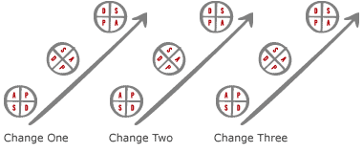

This method allows fairly rapid assessment of any intervention in a cost-effective manner.

1. Langley GL, Nolan KM, Nolan TW, Norman CL, Provost LP. The Improvement Guide: A Practical Approach to Enhancing Organizational Performance (2nd Edition). San Francisco, California, USA: Jossey-Bass Publishers; 2009. ISBN-10 0470192410 ISBN-13 978 0470192412
2. PDSA cycle diagram. How to Improve: Science of Improvement: Testing Multiple Changes. Cambridge, Massachusetts: Institute for Healthcare Improvement. <http://www.ihi.org/resources/Pages/HowtoImprove/ScienceofImprovementTestingMultipleChanges.aspx> (accessed 3 March 2015)