**Example Content for General Practice Repeat Prescriptions Policy to Incorporate Patient-Led Ordering of Medicines (PLO) in GM**

**This content should be incorporated into your repeat prescriptions guidance/ guideline/ process/ standard operating procedure (SOP) content and should be read in conjunction with NHS GM Patient-Led Ordering Rollout Activity Planner available to download from The Greater Manchester Primary Care Provider Board** [**GMPCB - Patient-led ordering**](https://gmpcb.org.uk/general-practice/working-with-community-pharmacy/patient-led-ordering/)

**Purpose**

Empowering patients to take control of ordering their own medication using the NHS app has many benefits both to patients and to the NHS including:

* Support self-care and empower patients to take control of ordering their medication within their capacity and capability
* Improve safety by avoiding stockpiling of medication and prevent medication that has been stopped from being re-ordered by mistake
* Reduce medicine waste by medicines not being ordered unless they are needed
* Save general practice (GP) and community pharmacy (CP) time (especially if prescriptions are ordered online) with less time spent chasing and processing prescriptions and answering the phone to queries and complaints
* Supports the improvement the GP/CP interface across GM

**Procedure**

**Prescription requests made by patients using the NHS app**

1. Process the request as per your usual practice procedure

**Prescription requests made by patients NOT using the NHS app**

1. Patients who are already identified on the agreed vulnerable patients list
   1. Process the request as per the agreed vulnerable patient procedure
2. Patients who are NOT on the agreed vulnerable patients list
   1. Review patient & identify if they should be confirmed as vulnerable (see the GM Roll Out Activity planner available on [GMPCB - Patient-led ordering](https://gmpcb.org.uk/general-practice/working-with-community-pharmacy/patient-led-ordering/))
   2. If the patient should be included in the agreed vulnerable list
      1. Liaise with the patient’s nominated community pharmacy to agree and confirm that the patient is vulnerable and should be on the agreed vulnerable list i.e. patient is excluded from using the NHS app to order their repeat medication
      2. The practice’s vulnerable patients list is updated to include the newly identified patient
      3. Patient’s medical notes are updated to reflect the vulnerable status in relation to ordering their medication and their exclusion from using the NHS app
      4. Process the request as per the agreed vulnerable patient procedure
   3. If the patient should NOT be included in the agreed vulnerable list
      1. If the medication request is urgent, then consider whether an exception to the use of the NHS app to request medication is warranted confirming the procedure to be used by the patient for future requests before processing the request as per the usual practice’s procedures. Patient to be provided with support and guidance around the use of the NHS app to order their repeat medication as required
      2. If the medication request is NOT urgent, then request the patient to resubmit their repeat medication request via the NHS app providing support and guidance around the use of the NHS app to order their repeat medication as required

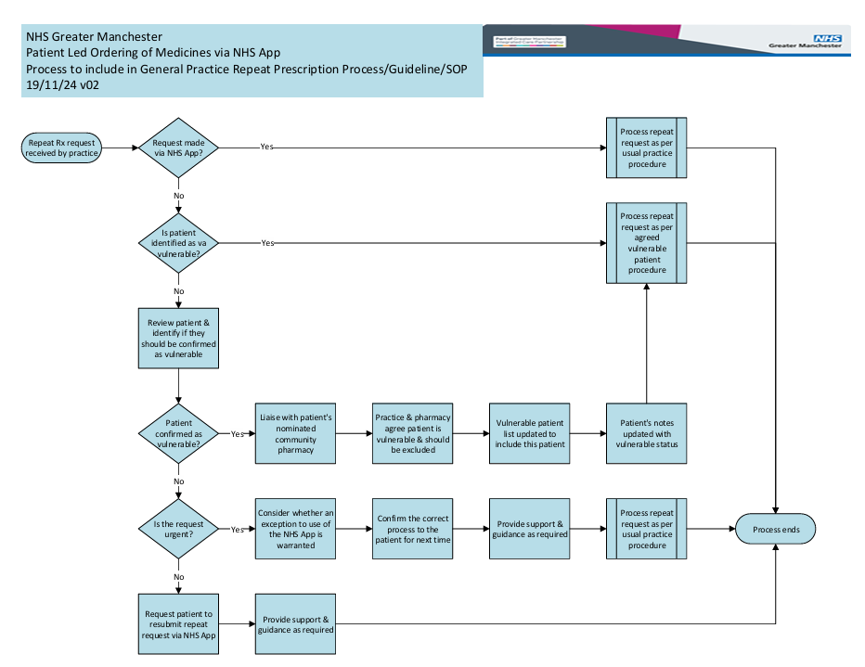

**Roles and responsibilities**

**Practice Manager**

* To incorporate PLO into their existing repeat prescriptions policy/ guideline/ guidance/ SOP/ process.
* Ensure all staff and clinicians have read and understood the patient-led ordering policy/ guideline/ guidance/ SOP/ process.
* Ensure nominated and new members of staff are trained on PLO
* Ensure that the policy/ guideline/ guidance/ SOP/ process is regularly reviewed in line with other general practice’s policies. Nominate a PLO champion for their practice.
* Take responsibility for adapting the GM EIA template for their practice.
* Ensure agreed vulnerable patients are appropriately supported.
* Taking responsibility for communicating PLO to patients
* Taking responsibility for communicating the changes to other key stakeholders e.g. affected community pharmacies

**Identified PLO Champions (Nominated practice staff member)**

* Act as the PLO champion within their practice
* Promote patient-led ordering using the NHS App and support vulnerable patients with ordering their medication. Maintain the agreed vulnerable list and ensure the requests from patients excluded from PLO are managed appropriately
* Resolve any patient queries or complaints relating to patient-led ordering. Escalate to the Practice Manager if unable to resolve
* Support with the identification of “vulnerable patients” who will require an alternative ordering option at rollout and ongoing basis

**Practice clinicians**

* Support the use of the NHS App for patient-led ordering with their patients.
* Support with the identification of “vulnerable patients” who will require an alternative ordering option at rollout and ongoing basis

**Other practice staff:**

* Support the use of the NHS App for patient-led ordering with their patients
* Support with the identification of “vulnerable patients” who will require an alternative ordering option at rollout and ongoing basis
* Resolve any patient queries or complaints relating to patient-led ordering if appropriate
* Escalate to the PLO champion/ Practice Manager if unable to resolve

**Prepared by:**

**Date:**

|  |  |  |  |  |
| --- | --- | --- | --- | --- |
| **Date of review** |  |  |  |  |
| **Reviewed by** |  |  |  |  |
| **Authorised by** |  |  |  |  |
| **Version number** |  |  |  |  |
| **Date of next review** |  |  |  |  |